ChandyMisraHaas(Deadlock)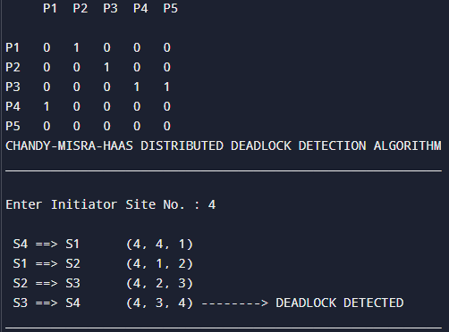

import java.util.Scanner;

public class DeadlockDetection {

static int[][] a = {

{0, 1, 0, 0, 0},

{0, 0, 1, 0, 0},

{0, 0, 0, 1, 1},

{1, 0, 0, 0, 0},

{0, 0, 0, 0, 0}

};

static int flag = 0;

public static void aman(int[][] a, int i, int k) {

int end = 5;

for (int x = 0; x < end; x++) {

if (a[k][x] == 1) {

if (i == x) {

System.out.println(" S" + (k + 1) + " ==> S" + (x + 1) + " (" + (i + 1) + ", " + (k + 1) + ", " + (x + 1) + ") --------> DEADLOCK DETECTED");

flag = 1;

break;

}

System.out.println(" S" + (k + 1) + " ==> S" + (x + 1) + " (" + (i + 1) + ", " + (k + 1) + ", " + (x + 1) + ")");

aman(a, i, x);

}

}

}

public static void main(String[] args) {

System.out.println(" P1 P2 P3 P4 P5");

System.out.println();

System.out.println("P1 0 1 0 0 0");

System.out.println("P2 0 0 1 0 0");

System.out.println("P3 0 0 0 1 1");

System.out.println("P4 1 0 0 0 0");

System.out.println("P5 0 0 0 0 0");

Scanner scanner = new Scanner(System.in);

System.out.println("CHANDY-MISRA-HAAS DISTRIBUTED DEADLOCK DETECTION ALGORITHM");

System.out.println("__________________________________________________________");

System.out.println();

System.out.print("Enter Initiator Site No. : ");

int i = scanner.nextInt();

int j = i - 1;

System.out.println();

for (int k = 0; k < 5; k++) {

if (a[j][k] == 1) {

System.out.println(" S" + (j + 1) + " ==> S" + (k + 1) + " (" + i + ", " + (j + 1) + ", " + (k + 1) + ")");

aman(a, j, k);

}

}

if (flag == 0) {

System.out.println("\nNO DEADLOCK DETECTED");

}

System.out.println("__________________________________________________________");

}

}

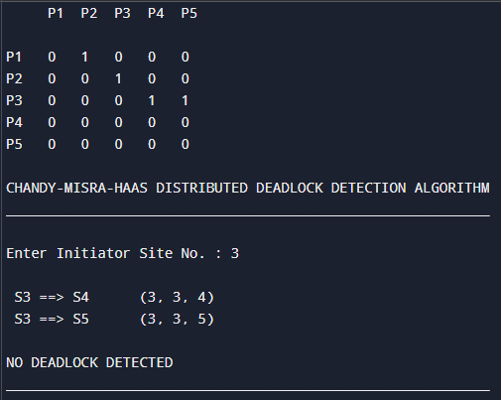

ChandyMisraHaas(No Deadlock)

import java.util.Scanner;

public class DeadlockDetection {

static int[][] a = {

{0, 1, 0, 0, 0},

{0, 0, 1, 0, 0},

{0, 0, 0, 1, 1},

{0, 0, 0, 0, 0},

{0, 0, 0, 0, 0}

};

static int flag = 0;

public static void aman(int[][] a, int i, int k) {

int end = 5;

for (int x = 0; x < end; x++) {

if (a[k][x] == 1) {

if (i == x) {

System.out.println(" S" + (k + 1) + " ==> S" + (x + 1) + " (" + (i + 1) + ", " + (k + 1) + ", " + (x + 1) + ") --------> DEADLOCK DETECTED");

flag = 1;

break;

}

System.out.println(" S" + (k + 1) + " ==> S" + (x + 1) + " (" + (i + 1) + ", " + (k + 1) + ", " + (x + 1) + ")");

aman(a, i, x);

}

} }

public static void main(String[] args) {

Scanner scanner = new Scanner(System.in);

System.out.println(" P1 P2 P3 P4 P5");

System.out.println();

System.out.println("P1 0 1 0 0 0");

System.out.println("P2 0 0 1 0 0");

System.out.println("P3 0 0 0 1 1");

System.out.println("P4 0 0 0 0 0");

System.out.println("P5 0 0 0 0 0");

System.out.println("\nCHANDY-MISRA-HAAS DISTRIBUTED DEADLOCK DETECTION ALGORITHM");

System.out.println("__________________________________________________________");

System.out.println();

System.out.print("Enter Initiator Site No. : ");

int i = scanner.nextInt();

int j = i - 1;

System.out.println();

for (int k = 0; k < 5; k++) {

if (a[j][k] == 1) {

System.out.println(" S" + (j + 1) + " ==> S" + (k + 1) + " (" + i + ", " + (j + 1) + ", " + (k + 1) + ")");

aman(a, j, k);

}

}

if (flag == 0) {

System.out.println("\nNO DEADLOCK DETECTED");

}

System.out.println("__________________________________________________________");

}

}